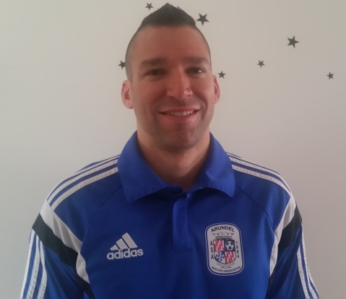
Brad Sanders
Head Coach, ASA Fire ’07 (Boys) and ASA Fire ’09 (Girls)

Coaching Experience:

Four years coed at JPYO in-house program, ages U4 through U8

One year, girls and boys, at ASA for in-house program and AAYSA Division 1, ages U8 and U9

Coaching Education:

NSCAA Level 2 – March 2015
USSF E – July 2015
USSF D – Attending Part I in 2016

Playing Experience:

25 years; youth experience included local AYSO, four years varsity at Fairfield High School, and travel club playing for Supernova FC ’82.

Player and Parent Expectations: Birth Year 2009 in AAYSA Division 1 or 2

Coaching Philosophy:

I focus most of my attention on player development and enjoy coaching players that love to play and show potential but are eager to learn how to maximize their abilities. When I interact with the players, I try to limit the amount of talking I have to do outside of actual training with the ball as much as possible. I think it’s more important to give players lots of positive feedback and technical correction as they train and play. I’m also very clear with my expectations and feedback; I always want my players to know when they are doing something well and when they need to improve so that they know the proper level of performance.

My training sessions emphasize ball mastery through a mix of repetitions and differential training. Skills and concepts are introduced with repetitions to increase player familiarity and comfort, and they are then honed through differential training so that the players have the opportunity to apply these skills and concepts in a variety of the same situations they will encounter in matches. This also promotes player independence and creativity because it allows them to interpret pressure or a challenge and select their own solutions, which leads to further education on why a particular solution did or did not work. All training sessions end with some sort of scrimmage, and most fitness is performed with the ball and in some sort of game or concept of play.

My goal in developing youth players is to give them the skills and soccer IQ needed to succeed in a variety of playing challenges. So I teach a variety of playing styles along with general concepts of play that will help them succeed as they grow. I also limit my roster size to 10 or 11 players so that my players get more minutes per match and have more opportunities to play in multiple positions. This team will train academy style with ASA Fire ’07.

Level of Commitment:

I expect my players to be training and playing with the team in fall, winter (indoor training and futsal), and spring. Summer will provide a break of six to eight weeks. Playing other sports is permitted, but the player must be available for at least one training session per week and most matches. The team will also play in at least two tournaments.

