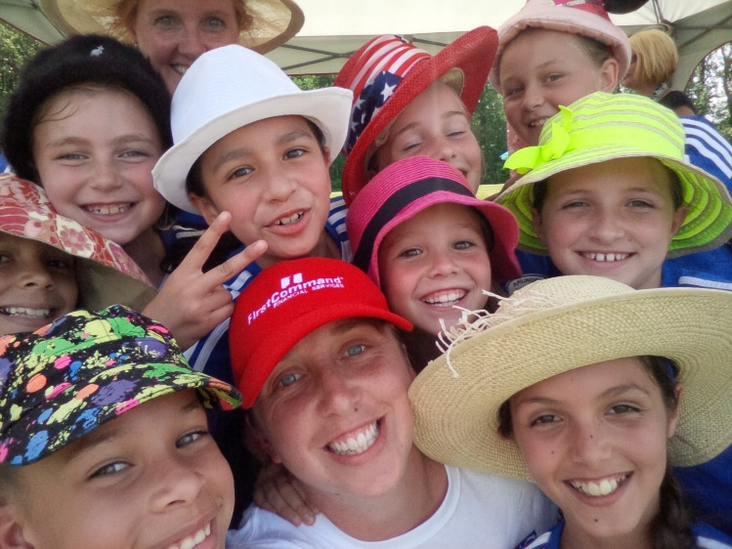

Gretchen Butler
2005 Girls
Played Soccer in College for Virginia Tech
Coach at ASA for 9 years
US Soccer E License
Plan on playing in one of the travel leagues in the area.
Players should expect to play year round (summers off). In the spring and fall we will have 2 practices a week. Over the winter the commitment is 1 day a week. Usually the 1st session of winter we play indoor and the 2nd session of winter we do a training session. We will also play 4 tournaments throughout the year, 2 in the fall and 2 in the spring.
I will be coaching these next few seasons with US Youth Soccer ideas of measuring success. We are training, playing in games and tournaments to build the fundamental skills to allow players to continue to be successful in their soccer development. It is not to say that winning isn’t important, we all want to win. But I will not sacrifice the development of our players for a win. The goal is not to have these players be the best at 10 and 11, but to give them the highest probability of being the best at 17, 18 and 19.
Season Training Goals
Individual: Ball Mastery
Team: Possession

