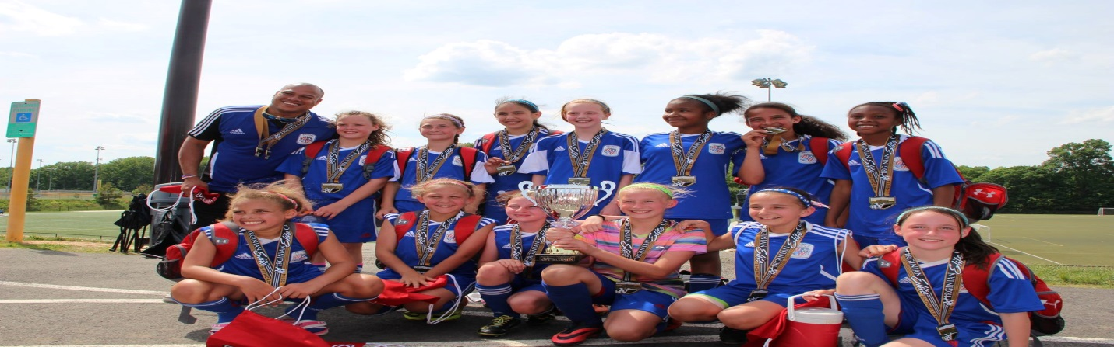

Introduction
My name is Richard Wilson and I will coach ASA Arsenal 2006 and 2007 girls. I am a Dad of 3 girls (12, 8 & 6) played at Howard Community for a year until got injured. I have my D and E license (National) I have been with the ASA organization for 8 years coaching my older daughters team ASA Arsenal 03. Some of our accomplishments include ranking as high as 12th in Maryland, winning the Presidents Cup (representing MD) winning the Virginia Elite. We were finalist 5 times (OBGC, Columbia Invitational and Hershey Park) throughout the years.

I currently coach a 2006 travel and county team. These teams are a mix of both ages but will split into a 2006 and a 2007 travel team (WAGS) team in the fall.

League Play
We played in the CMSSL league and did not lose a game in the fall season so we joined WAGS this spring and are continuing until we can qualify for higher level leagues like EDP, CCL and Region 1. This team won Mountain road, lost in the final at OBGC cup in Bethesda and lost in the semi-finals of the Columbia invitational.
We will play fall soccer, futsal, indoor and then spring soccer. We can do summer soccer as an option (Super Y) in the future. We will compete in 2 scrimmagefests, 6-8 tournaments throughout the season and have a professional trainer for a week of training camp to begin our season. We want to build a team that requires a high level of commitment to play top competition soccer and also play in all major holiday weekend tournaments.

Philosophy
I expect a positive sideline where every parent cheers for the team, players attend practice on time and have fun in a competitive environment. We will have a code of conduct guideline that parents and players will use as a guide.
I think that players get better with game time so playing time will be close to even as I can. Development of ball skills is always a practice focus in addition to passing, receiving and moving without the ball. We will strive to be a technical, possession based team

Practice days Monday / Wednesday 2007 Team Practice days Tuesday /Thursday 2006 Team

