Coach Steve Tarallo
ASA Vikings ‘06
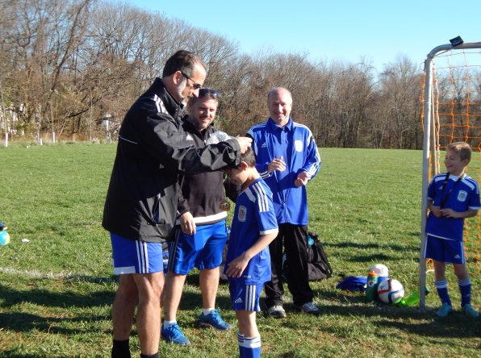
Coach Steve Tarallo is a Northport, NY native who as a youth played for Northport Soccer Club travel teams and was a Long Island Junior Soccer League select player. He was a 3-year starter on both his middle school and Northport High School (NHS) varsity teams. During his senior year at NHS, the team was a finalist in the Suffolk County championship. Coach Steve was recruited by several D3 teams from small liberal arts colleges, but decided instead to attend Villanova University and focus his time and attention on earning his mechanical engineering degree.
Coach Steve has played recreational soccer and remained passionate about the sport throughout his adult life. As a lifelong student of the sport, Coach Steve was excited to volunteer as coach of his son Alex’s ASA Clinic team in 2012 and share his knowledge, experience, and passion for soccer with young players.
Coach Steve has coached youth soccer for 4 years. After 4 seasons coaching Clinic and Juniors teams and developing players for higher levels of competition, he coached the ASA Vikings U8 team to a 9-1 record in Division 2 county league (AAYSA) during the 2014 Fall season. The Vikings quickly advanced to AAYSA Div. 1 in the 2015 Spring season and travel league (NCSL) as U9 last Fall. The Vikings are currently playing their second season as a NCSL U9 travel team. He earned his MSYSA E-license in July 2014.
Coach Steve’s player development philosophy has five primary goals:
- To develop technically competent soccer players who are able to skillfully receive, dribble, pass, and shoot the ball. Emphasis is placed on players’ abilities to control the ball with their first touch and defend with confidence in all areas of the field.
- To develop players’ tactical abilities in the areas of mobility, proper positioning, space creation, and support.
- To develop players’ agility, balance, coordination, speed, and acceleration through soccer training drills that challenge each player to beat his previous personal best performance
- To help players become critical, independent thinkers on the field by creating game-like situations and a player-centered (not coach-centered) environment where players are allowed to express themselves through creativity and improvisation.
- To instill a team spirit by ensuring each player understands that every player on the team has an important role to play.

