Jim Deal Head Coach – ASA Alliance 04 Boys U14 – Division 1 - BBSL

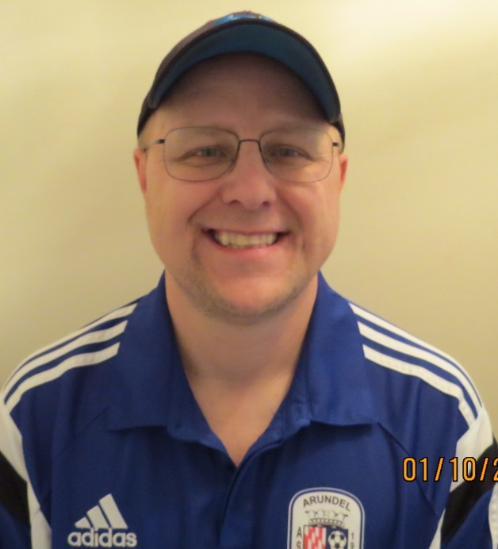
TEAM EVENTS:
AA County D3 Winner – 2014
Arundel Cup Finalist – 2014
AA County D2 Winner – 2015
Arundel Cup Winner – 2015
Odenton Sports Futsal Winner – 2016
AA County D1 Winner – 2016
Sand Duels Finalist – 2016
IFK Invitational Winner - 2016
BBSL D1 Travel Winner – 2016
Lutherville Timonium Cup Winner - 2016
Odenton Sports Futsal Winner - 2017
Coerver API Tournament Winner – 2017
Soccer dome Indoor Soccer Winner – 2017

TEAM STAFF:
- Head Coach: Jim Deal
- Assistance Coach: Steve Bell
- Assistance Coach: Scott Smith
- Equipment Manager: Kristen Deal
- Team Treasurer: Barbara Aldridge

TEAM BACKGROUND:
ASA Alliance is a high level travel team currently competing in BBSL Division 1. Members of this team are expected to have a high level of dedication and commitment. ASA Alliance trains year round and will play in 4-5 tournaments a year to include major holidays such as Memorial Day. The costs for the fall 2016/spring 2017 season (Aug-June) are expected to be between $1,000 per player.

TEAM SPECIALIZED TRAINING:
- Strictly Soccer Academy. Team receives specific technical and tactical training from Director/Coach, Rob Chalmers. Training specializes in technical and tactical development and includes various Strictly Soccer Camps.
- Anne Arundel Community College Soccer Program. Involvement includes working directly with college players at the AACC Campus. Also includes tailored training sessions with the Head Coach of the AACC Men’s Soccer team, Nick Cosentino. Alliance players attend multiple AACC home games where they are active participates in game activities (i.e. part of on field warm up sessions, running the sidelines during games, assisting coaches and players when needed during games).
- Coerver Soccer (API Facility in Gambrills, MD). Throughout the year, the team attends multiple sessions of agility, acceleration, and technical and tactical training with Coerver Coaching Technical Director, Ryan Parisi. Team also attends various Coerver sponsored soccer events and camps.
- Team receives soccer training from various D.C. United Professional players via various sponsored soccer camps offered throughout the year. Team also participates in on field activities during D.C. United matches (i.e. tunnel activities, pre-warm up activities, mini-halftime games, and opening ceremonies).
- Team participates in two Winter Futsal sessions at either Benfield Sports Facility or the Odenton Sports Complex. Great for conditioning and ball mastery.
- Team receives routine Goalkeeper Training from the Head Coach of the Anne Arundel High School Soccer Program, Zak Kruger. Zak attends two Alliance practices per week.

PERSONAL BACKGROUND:
- Grew up and still live in Anne Arundel County, near the BWI Airport.
- Graduated from Anne Arundel High School – 1989
- Howard Community College (1990-1991)
- Towson State University (1992-1995)

~ Played Football, Basketball, Soccer, Baseball, and Lacrosse
------------------------------------------------------------------------------

VOLLEYBALL:
Played on the EVP® Armature Beach Volleyball Tour (1985-1989)

LACROSSE:
Played for the Baltimore Thunder Professional Lacrosse Team (1992-1993)
- National Lacrosse League, Baltimore Arena
- Coach – John Stewart
- Best season – American 6-4, Division Champs, Lost in semifinals

Strictly Soccer Academy (Technical Instructor):
- Provide detailed agility and conditioning training through team sponsored events and yearly camps.

Odenton Sports Complex (Athletic Director):
- Currently provide technical and tactical instruction toward soccer, basketball, and volleyball related activities.
- Creator and Senior Coach for the soccer pick-up program where players from all backgrounds, all locations, with our without experience, can play with little to no instruction. This is to facilitate unstructured play and encourage the sense of creativity.

Source Soccer 360:
- Provide direct support to the Director, John Dingle with regards to providing soccer education at its best for your child. Organization creates a learning environment enjoyable and stress free. Goal is to develop natural ability, improve techniques, and create skillful and sportsmanlike soccer players which will enable each to enjoy soccer to its fullest. Involvement includes training, camps, and volunteer work.

COMMISSIONER ROLES:
- Andover Apache Football Coach & Commissioner (2008 - 2010)
- Linthicum Ferndale Softball Coach & Commissioner (2004 - 2008)
- Harundale Soccer Coach & Commissioner – (2011-2013)

OTHER COACHING EXPERIENCE:
Girls Basketball
Girls Softball
Boys Baseball
Boys Basketball
Boys Lacrosse
Boys Football
North County High School Volleyball
North County High School Softball
LICENSE/CERTIFICATES

G License (Massachusetts (Holliston) Youth Soccer): Designed primarily for coaches of U6 – U8 players. The course will help you to become a more resourceful and confident “activity leader” – to combine your enthusiasm and commitment to children with the basic theory and practical exercises that will provided.

F License (Massachusetts State Youth Soccer Association): Designed primarily for coaches of U9 – U10 teams. The F course is a natural progression of instructional material and content. The course helps you continue to grow and develop as an “activity leader”. You will learn the essentials of practice organization and game day conduct.

E License (Maryland State Youth Soccer Association): This instruction combines soccer theory and practice. The course is designed to improve skill development with concentrating on creating more organized, age-appropriate training sessions, developing coaching practices and creating an environment that is fun for the players. This course is designed primarily for experienced coaches of U11 – U14 teams.

PRO-1 Goalkeeping Academy Certification: This U.S. Soccer accredited certification is designed towards the more experienced team coach who has never played the goalkeeper position.

U.S. Soccer/Grade 8 Referee Certification: This training is specific to the competitive youth game.

International Sports Sciences Association (Personal Trainer Certification): Course designed toward Fitness nutrition, Sports conditioning, Health Coach Sports Conditioning, and Youth Fitness.

International Youth Conditioning Association (Youth Conditioning Certification): The IYCA is designed toward the finest educational programs in the realm of youth athletic development and fitness. Certification designed toward preventing sports related injuries (i.e. ACL, Hips, Back, Neck, and Ankles).

Precision Nutrition (Sports Nutritionist Certification): Designed for personal trainers, strength trainers, group fitness instructors, athletes of all levels. Instruction consists of enhancing youth workouts and to maximize their results with proper nutrition, safe and effective sports supplements, and beneficial vitamins and minerals.

